**Experiment 1**

**Q.1 Write a program to subtract 16-bit number.**

**Statement: -**

Subtract number 1234H and 4897H and store the result in memory location 2055H and 2056H.

**Program: -**

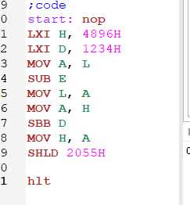

**Output: -**

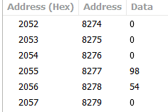

**Registers: -**

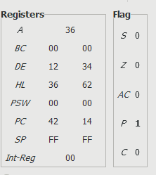

**Q.2 Write a program to subtract 16-bit number.**

**Statement: -**

Input first number from memory location 2050H and 2051H and second number from memory location 2052H and 2053H and store result in memory location 2055H and 2056H

**Program: -**

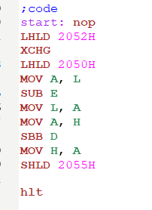

**Output: -**

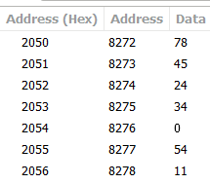

**Registers: -**

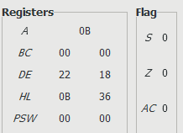

**Q.3 Write a program to multiply two 8-bit numbers.**

**Statement: -**

Multiply 06 and 03 and store result in memory location 2055H.

**Program: -**

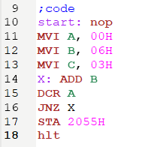

**Output: -**

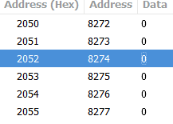

**Registers: -**

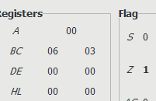

**Q.4 Write a program to divide 8-bit numbers**

**Statement: -**

Divide 08H and 03H and store quotient in memory location 2055H and remainder in memory location 2056H.

**Program: -**

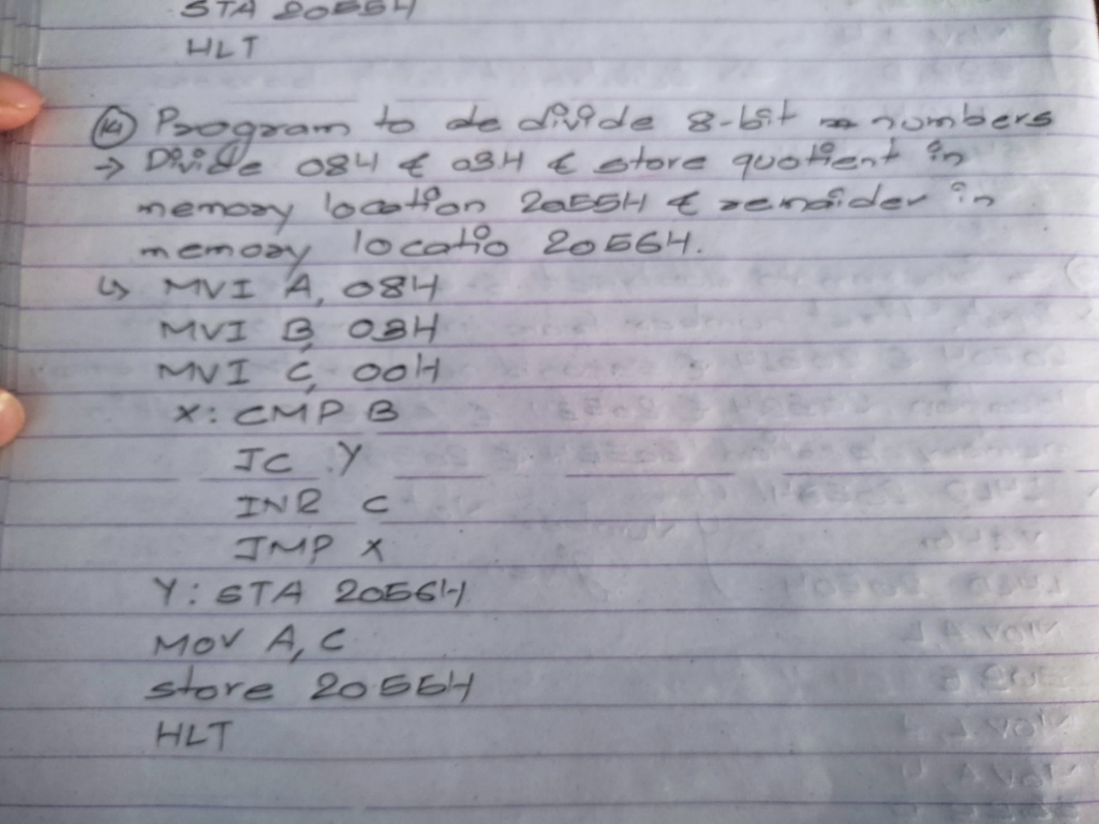

**Q.5 Write a program to find greatest among two 8-bit numbers.**

**Statement: -**

Input two numbers from memory location 2050h and 2051h and store greatest number in memory location 2055h.

**Program: -**

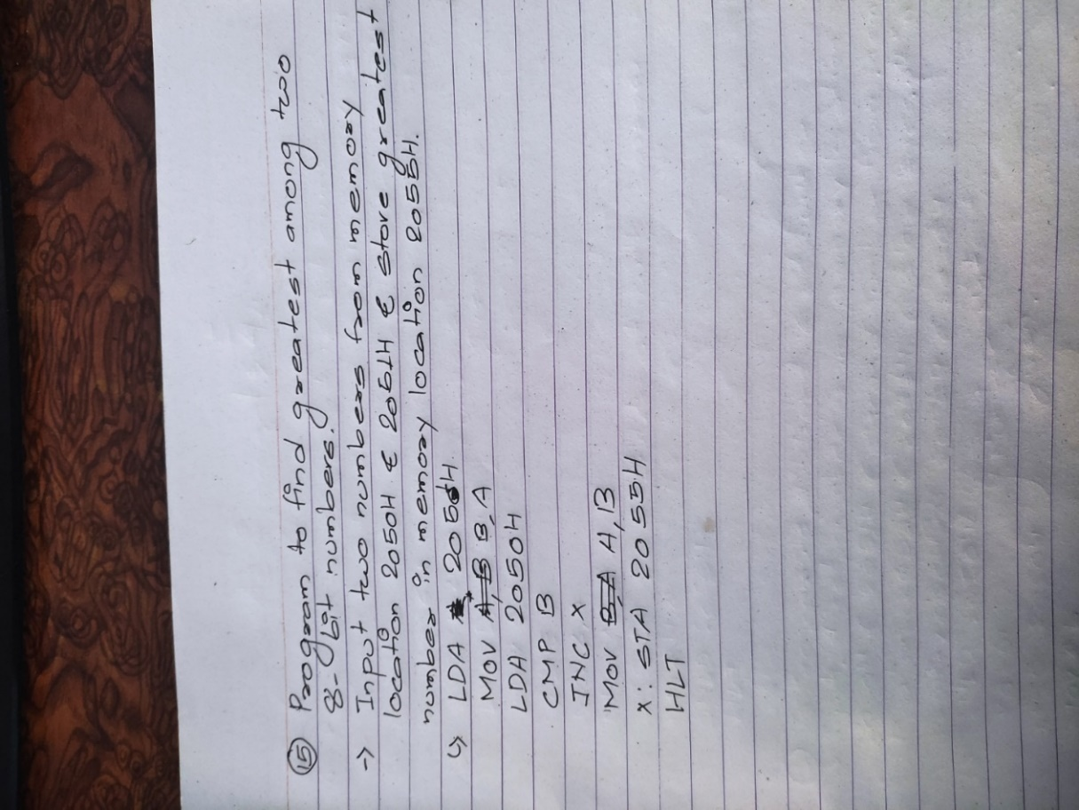

P.S.

The GNUsim8085 application kept on crashing so I had to insert pictures.